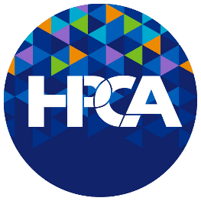
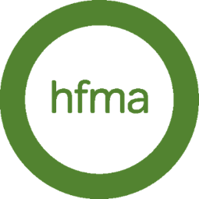
HPCA in Person Workshop
Change Management Workshop – Getting Started in Change Management

Booking Form

Supplier details:  HFMA  HFMA House  4 Broad Plain  Bristol  BS2 0JP  Payment Reference:  HPCA Virtual Training – Mastering Programme Initiation | Bank Details:  HFMA  Nat West  Account Number – 32715102  Sort code – 604008
PLEASE COMPLETE THE FORM & RETURN TO training@hpca.uk
^{DATE: DD/MM/YEAR}
Customer Details

Organisation Name: |  | Purchaser Name:
Address: |  | Delegate Name
 |  | Tel No:
 |  | Email:
Invoicing Address:  (If different to above) |  | PO/REF:
 |  | Credit Card Payment | Please call HFMA on:  0117 929 4789 and press option 2

Course Details
PLEASE RETURN THIS COMPLETED FORM TO training@hpca.uk

DETAILS:  Change Management Workshop  With Jooli Atkins  1 full day  25th June– LONDON – 1 full day | CHARGES: | TERMS & CONDITIONS/DETAILS for HPCA Training:  - Credit card payment or PO number must be provided prior to the date of the course.  - No show/Cancellation fee – No refund where cancellation is received with less than 2 weeks' notice of the first module start date.  - If cancellations are within 2-4 weeks, please contact us and we will discuss on a case-by-case basis.  - Substitutes – tickets can be substituted to a named delegate up until 2 days prior to the event starting, please contact us with details.  - If for any reason HPCA need to cancel the event, we will reschedule your booking to next cohort.  - On completion of the course HPCA will issue each user with a certificate of attendance within 24 hours.
Total Cost: (per person EX VAT) | £250.00

Signed on behalf of organisation: | Signed on behalf of HFMA/HPCA:
Name: | Name: Helen Bellis
Signed: | Signed: Helen Bellis
Position: | Position: Business Manager

PLEASE RETURN THIS COMPLETED FORM TO training@hpca.uk

By signing this order form, the Customer agrees to enter into a contract for the provision of the above e-learning services with HFMA and to be bound by the HFMA terms and conditions for the supply of e-learning services. Such terms and conditions can be located at https://www.hfma.org.uk/online-learning/subscriptions-for-organisations and a hard copy shall be provided by HFMA upon request. Please keep a copy of this document for your reference

